**AIR QUALITY MONITORING USING IOT**

**Team :**

|  |  |
| --- | --- |
| **S.no** | **Name** |
| **1.** | **Raja.M** |
| **2.** | **Suriya.R** |
| **3.** | **Ashok.S** |
| **4.** | **Chandru.S** |
| **5.** | **Sachin.V** |
| **6.** | **Balaji.P** |

**INTRODUCTION:**

Air quality management refers to all the activities a regulatory authority undertakes to help protect human health and the environment from the harmful effects of air pollution. Air quality management refers to all the activities a regulatory authority undertakes to help protect human health and the environment from the harmful effects of air pollution.

**ABSTRACT:**

1. In most urban areas of the world, particulate matter (PM) levels pose severe problems, addressed in several policy areas (air quality, climate change, and human health). PM presents multiple challenges due to the multitude of its sources, spanning many sectors of economic activity as well as nature, and due to the complexity of

atmospheric processes involved in its transport and secondary formation.

1. For the authorities, the goal is to assure minimal impacts of atmospheric PM levels, in practice represented by compliance with existing regulations and standards. This may be achieved through an air quality management plan (AQMP).
2. The main purpose of the AQMP development process is to establish an effective and sound basis for planning and management of air quality in a selected area.
3. This type of planning will ensure that significant sources of impacts are identified and controlled in the most cost- effective manner. The choice of tools, methods and input information is often dictated by their availability, and should be evaluated against current best practices. Important elements of the AQMP are the identification of sources and development of a complete emission inventory, the development and operation of an air quality monitoring programme, and the development and application of atmospheric dispersion models.
4. : Air Quality Management System (AQMS) requirements, operational and functional structure requirements, source identification through emission inventories, source reduction alternatives, which may be implemented, mechanisms for facilitating interdepartmental cooperation in order to assure that actions are being taken and institutional building and training requirements.

[Energy neutral design of an IoT system for pollution monitoring](https://ieeexplore.ieee.org/abstract/document/8052691/)

* A lot of research and studies have shown the impact of pollution on health, and a lot of regulation are in action in the European Union and other countries around the world defining the allowed concentration levels of volatile chemicals.
* Standard measurements equipment are very expensive, and static large stations require space and high power consumption, thus are not suitable to realize portable equipment nor to seamlessly be integrated in Smart Cities. In this paper we present the design and evaluation of a portable pollution monitoring equipment as small as 20×15×5 cm, powered by mini PV arrays, embedding particulate matter and CO/VOCs sensors for air quality estimation.
* A LoRa radio transceiver completes the set of peripherals. Finally, energy budget analysis shows that neutral operations can be achieved enabling a “deploy and forget” paradigm suitable for the IoT.

**Mobile Air Quality Monitoring**



Hyperlocal air quality data can be collected using mobile IoT technologies such as those used by MTG.

Installing IoT air quality monitoring sensors on vehicles is another way of achieving hyper-local pollution data. Vehicles such as bin lorries, buses and council vehicles regularly drive throughout most urban and residential areas. Installing IoT air quality stations on cars along with GPS systems – is another way to achieve hyper-local air quality data without having to invest hundreds of sensors in fixed locations. MTG has trialled mobile [hyperlocal air quality monitoring](https://www.manxtechgroup.com/mobile-air-quality-monitoring-with-iot/) tech trials in the Isle of Man – delivering hyper-local measurements in a cost-effective manner.

**System Model:**

**The system is designed by using hardware components operated by software and programming tools that are discussed below.**

**2.1. Hardware Components**

**The hardware components used in the system is NodeMCU as a micro-controller NodeMCU gives the ability to openly perform editing, modification, and rebuilding of project programs and functions through different programming environ- ments . MQ series gas sensors include MQ-7 to detect carbon monoxide , MQ-4 to detect methane [6 ], MQ-2 to detect smoke and LPG , MQ-137 to detect ammonia gas, and MQ 135 to detect overall pollutants These sensors detect gasses like Methane, CO, LPG, and overall air quality. MQ Series Gas Sensors are composed of micro-AL2O3 ceramic tubes, Tin Dioxide (SnO2) sensitive layer, measuring electrodes, and heater, which is fixed into a crust, composed of plastic and stainless steel net MG-811 gas senor to detect carbon dioxide is used from MG series sensors. This sensor has a rapid response and recovery characteristics with low-temperature dependency and humidity** .

# Air Monitoring or Testing Procedure

* Before starting air monitoring or air testing on-site there is some background information required of the sources/emissions, health and demographic information, meteorological data, topographical information and previous air quality monitoring information. 
* It helps to decide whether to increase or decrease monitoring locations based on previous readings. 
* Air quality testing and monitoring are done in areas where pollution problem exists and it is expected e.g. Companies Premises, Industrial area, traffic intersection. 
* It is good to conduct Air Pollution Testing program in order to get annual average sampling as pollutants behave in each season differently. 

 

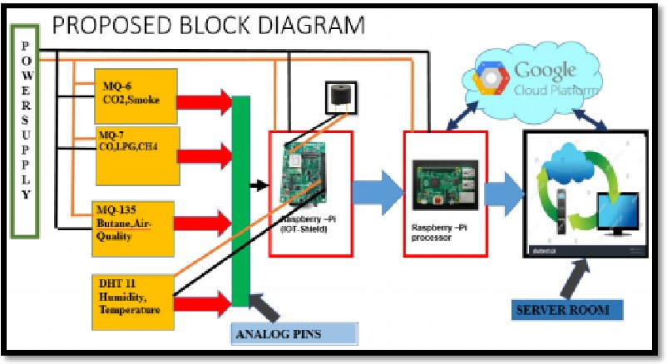 

 

* It recommended that in a year 104 Air emissions monitoring of 24 hrs. i.e. twice a week. 

**Air Quality Monitor Sonser**

* DIY Arduino air quality monitor which can measure surrounding air quality also shows temperature and humidity in your room. 

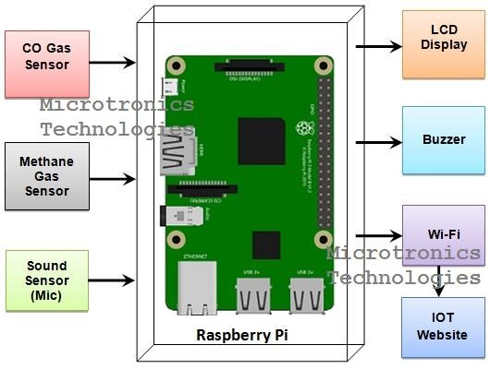

**Project description**

* M any times we feel very weak while waking up from the bed even after getting a good sleep at night. 
* This sometimes happens because of the poor air quality in the closed room at night. 
* This is a low cost Air Quality Monitor which can monitor the air quality of a room using MQ135 air quality sensor. 
* It also measure the room temperature and humidity using DHT11 and shows the data on a OLED display. It is a fun little project and very helpful too. 

**Potential impact around the globe?**

* **There are many cities around the world facing air quality issues. The contaminated air results in death every year and decline in health conditions as people are exposed to unhealthy air quality.**
* **Awareness of the contaminated air enables the community to take precautionary steps. This will also enable the relevant authority to take remedial action.With this project the community can enjoy cleaner air and improved health conditions.**

**Objectives**

* **To design an innovative air quality monitoring system that can cover one square kilometer of urban area**

* **To monitor the air quality index through smartphone and smartwatch applications from installed sensors on buildings with height ranges of 3 meters to 6**

**meters**

* **To propose preventive actions through smartphones and smartwatch applications when the air quality level exceeds threshold values.**

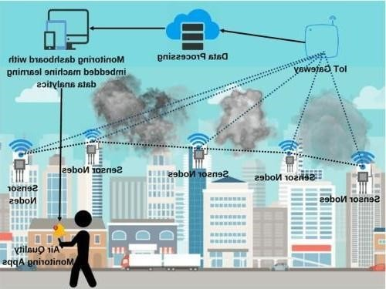

**Types of sensors:**

* Airly PM – it measures PM 1, PM 2.5, PM 10 parameters as well as temperature, humidity, and pressure.
* Airly PM+GAS type 1 – it measures PM 1, PM 2.5, PM 10, NO2, O3, pressure, humidity, and temperature.
* **Volatile organic compound (VOC) sensors** are available that are capable of detecting volatile chemicals and odorous pollutants.
* **deployed in strategic locations to measure pollutant levels such as particulate matter, gases, and volatile organic compounds (VOCs)**.
* **Any gas which can be oxidized or reduced electrochemically can be detected by means of a fuel based electrochemical sensor**.

**WORKING**

* The MQ135 sensor can sense NH3, NOx, alcohol, Benzene, smoke, CO2 and some other gases, so it is perfect gas sensor for our Air Quality Monitoring Project. When we will connect it to Arduino then it will sense the gases, and we will get the Pollution level in PPM (parts per million). MQ135 gas sensor gives the output in form of voltage levels and

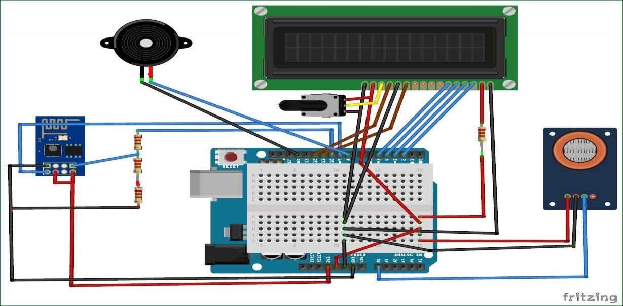

|  |
| --- |
| we need to convert it into PPM. So for converting the output in PPM, here we have used a library for MQ135 sensor, it is explained in detail in “Code Explanation” section below.  •   •Sensor was giving us value of 90 when there was no gas near it and the safe level of air quality is 350 PPM and it should not exceed 1000 PPM. When it exceeds the limit of 1000 |
| PPM, then it starts cause Headaches, sleepiness and stagnant, stale, stuffy air and if exceeds beyond 2000 PPM then it can cause increased heart rate and many other diseases.  •When the value will be less than 1000 PPM, then the LCD and webpage will display “Fresh Air”. Whenever the value will increase 1000  PPM, then the buzzer will start beeping and the  LCD and webpage will display “Poor Air, Open Windows”. If it will increase 2000 then the buzzer will keep beeping and the LCD and webpage will display “Danger! Move to fresh Air”. |

**AIR**

**QUALITY**

**CHECKING**

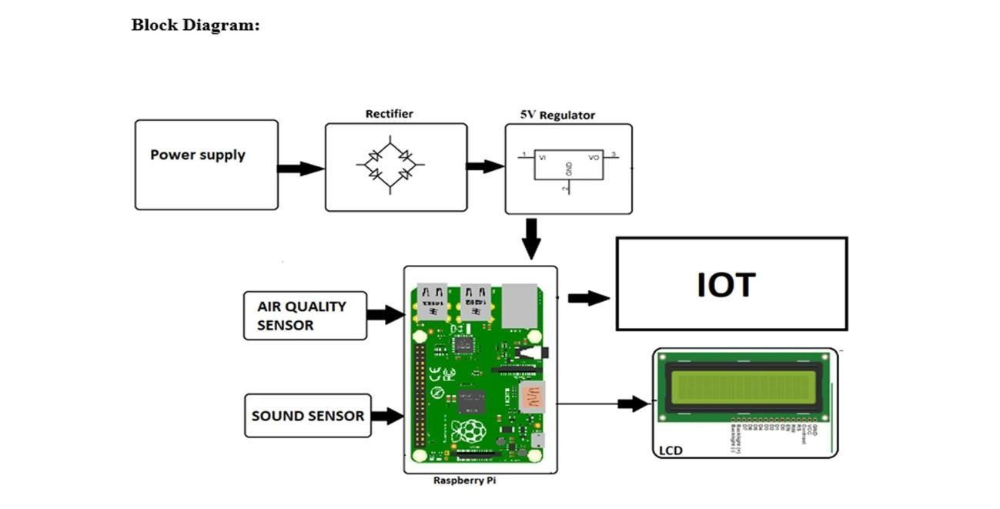

* **Air Now :** is your one-stop source for air quality data. Our recently redesigned site highlights air quality in your local  area first, while still providing air quality information at state, national, and world views. A new interactive map even lets you zoom out to get the big picture or drill down to see data for a single air quality monitor.
* **Air Now Fire and Smoke Map :** is designed to provide the public additional information on levels of particle pollution

(PM2.5) in the air during fires. 

* **Air Quality Flag Program :** each day your organization raises a flag that corresponds to how clean or polluted the air is. The colour of the flag matches EPA’s Air Quality  Index (AQI): green, yellow, orange, red, and purple.
* **Air Sensors Toolbox :**Air sensor monitors that are lower in cost, portable and generally easier to operate than regulatory-grade monitors are widely used in the United States to understand air quality conditions. The EPA is involved in the advancement of air sensor technology, including performance evaluations of sensor devices and best practices for effectively using sensors. 

**How does IOT reduce air pollution**?

* IOT (Internet of Things) plays a crucial role in reducing air pollution through its ability to collect real-time data and enable smart decision-making. 

* Iot devices, such as air quality sensors, can monitor pollutant levels in various environments, including cities, industries, and homes. 
* This data can be analysed to identify pollution sources, implement targeted mitigation strategies, and track the effectiveness of pollution control measures. IOT-enabled smart city solutions optimize transportation, waste management, and energy consumption, reducing emissions and improving air quality. 

**Conclusion:**

The health of the public, especially those who are the most vulnerable, such as children, the elderly and the sick, is at risk from air pollution, but it is difficult to say how large the risk is. It is possible that the problem has been over-stressed in relation to other challenges in the field of public health.

As we have seen, there are considerable uncertainties in estimating both exposures and effects and their relationships. It may be, for example, that the effects of long-term exposure to lower concentrations of air pollutants could be more damaging to public health than short- term exposure to higher concentrations. For this reason alone, local authorities could take action to assess and improve local air quality. It is not sufficient to wait for an episode of severe air pollution and then try to deal with its effects.

However, the old and the young, and especially those suffering from respiratory or heart diseases, are the groups who are most vulnerable to the effects of air pollution. It is only right that cost effective action should be taken to provide them with clean air, which The Times of 1881 described as “the first necessity of our existence.”